**DETAILS**



# Waterpower Day Toolkit

Celebrate with us on June 20

## When is Waterpower Day ?

June 20, 2025

## Hashtags

**#WaterpowerDay**, #WaterpowerDay2025

## Tag the OWA

**LinkedIn:** [Ontario Waterpower Association](https://www.linkedin.com/company/ontario-waterpower-association?trk=tyah&trkInfo=clickedVertical%3Acompany%2CclickedEntityId%3A3216266%2Cidx%3A4-1-4%2CtarId%3A1486476680210%2Ctas%3Aontario%20waterpower%20associat)

**Instagram:** [onwaterpower](https://www.instagram.com/onwaterpower/)

**X (Twitter):** [ONWaterpower](https://twitter.com/ONWaterpower)

**Facebook:** [Ontario Waterpower Association](https://www.facebook.com/ONWaterpower)

## Questions?

Email Janelle Fonseca,

Communications and Community Outreach Manager at [jfonseca@owa.ca](mailto:jfonseca@owa.ca)

**Graphics and Captions**



# Graphics and Captions

To help you celebrate the day, the OWA has created graphics and captions for you to use on social media. Share a post on your personal platforms and pass this toolkit along to your company's communications team.

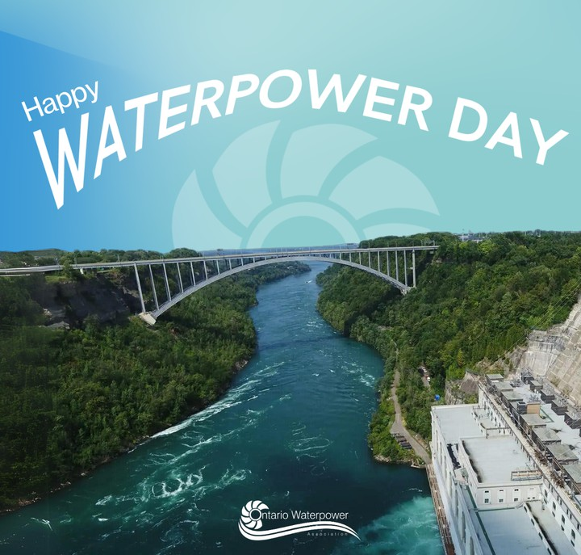On #WaterpowerDay, we proudly celebrate the rich history, ongoing contributions, and bright future of made-in-Ontario waterpower. As a cornerstone of the renewable energy sector, waterpower provides affordable, reliable, and sustainable energy. https://tinyurl.com/3yhyk4x5



## [Download Graphic Here](https://owa.ca/wp-content/uploads/2025/03/Waterpower-Day-Graphic-8.png)

Today we are proud to celebrate affordable, reliable, and sustainable waterpower. Waterpower has been a cornerstone of Ontario’s clean energy mix for generations, driving economic growth, supporting communities, and helping us accelerate Ontario’s electrification. Happy #WaterpowerDay! https://tinyurl.com/3yhyk4x5

[**Template - Add Your Logo**](https://www.canva.com/design/DAGiG5Kiwf8/V9Lu1bBsHFyn8ExjXt63wg/view?utm_content=DAGiG5Kiwf8&utm_campaign=designshare&utm_medium=link&utm_source=publishsharelink&mode=preview)

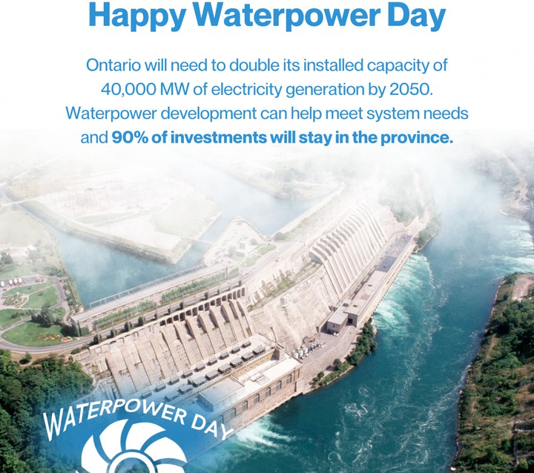Waterpower isn’t just our past—it’s our future. Ontario will need to double its installed capacity of 40,000 MW of electricity generation by 2050. Investing in waterpower development can meet system needs and provide significant local, regional, and provincial socio- economic benefits. Happy #WaterpowerDay! https://tinyurl.com/3yhyk4x5



## [Download Graphic Here](https://owa.ca/wp-content/uploads/2025/03/Waterpower-Day-Graphic-2.png)

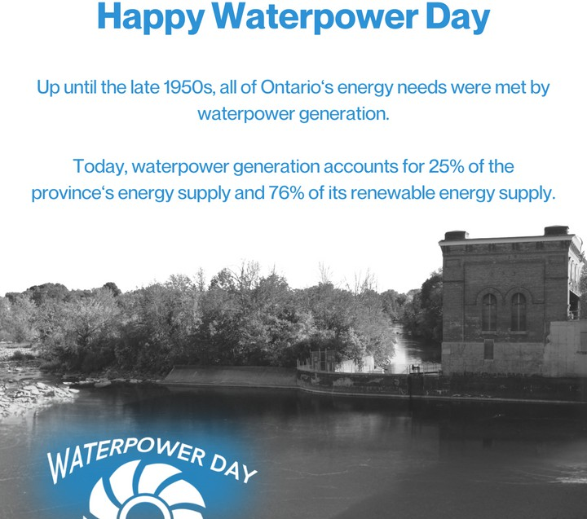Up until the late 1950s, all of Ontario‘s energy needs were met by waterpower generation. Today, waterpower generation accounts for 25% of the province‘s energy supply and 76% of its renewable energy supply – now that’s something to celebrate! Happy #WaterpowerDay! https://tinyurl.com/3yhyk4x5

[**Download Graphic Here**](https://owa.ca/wp-content/uploads/2025/03/Waterpower-Day.png)

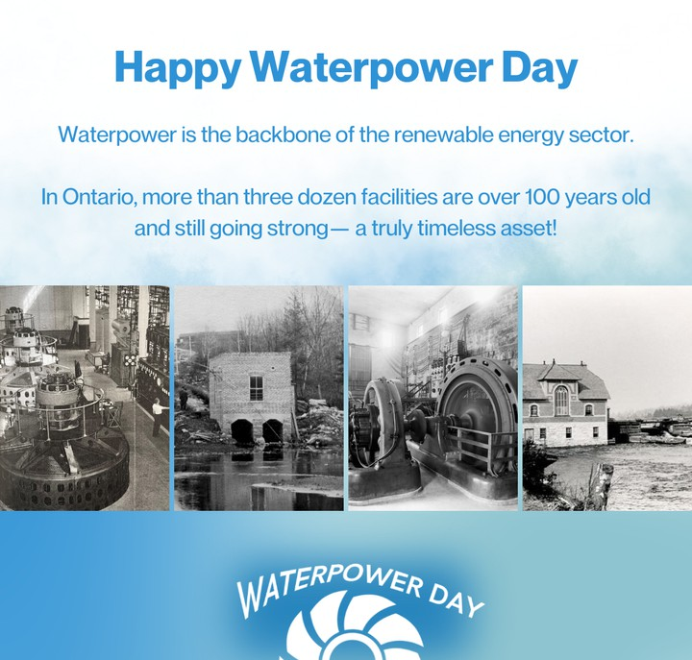It’s #WaterpowerDay! Waterpower is Ontario’s original renewable resource providing affordable, reliable and sustainable energy for generations. More than three dozen facilities across the province have been operating for 100+ years and still going strong. https://tinyurl.com/3yhyk4x5



## [Download Graphic Here](https://owa.ca/wp-content/uploads/2025/03/Waterpower-Day-Graphic-4.png)

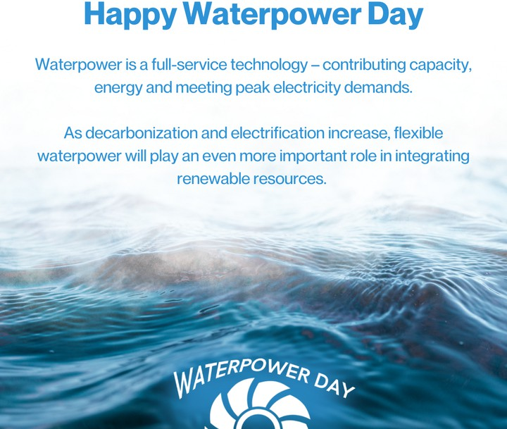Waterpower is the backbone of the renewable energy sector. It’s a full-service technology – contributing capacity, energy and meeting peak electricity demands. As decarbonization and electrification increase, flexible waterpower will play an even more important role in integrating renewable resources. Happy #WaterpowerDay! https://tinyurl.com/3yhyk4x5

[**Download Graphic Here**](https://owa.ca/wp-content/uploads/2025/03/Waterpower-Day-Graphic-5.png)

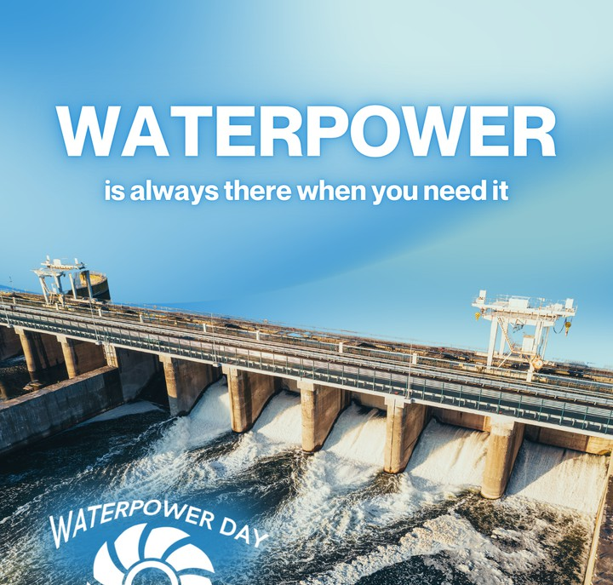When the sun isn’t shining and the wind isn’t blowing, waterpower is there. Most of Ontario’s waterpower facilities can follow changes in demand and supply by storing energy (i.e. water) and shifting production to meet system needs. #WaterpowerDay https://tinyurl.com/3yhyk4x5



## [Download Graphic Here](https://owa.ca/wp-content/uploads/2025/03/Waterpower-Day-Graphic-7.png)

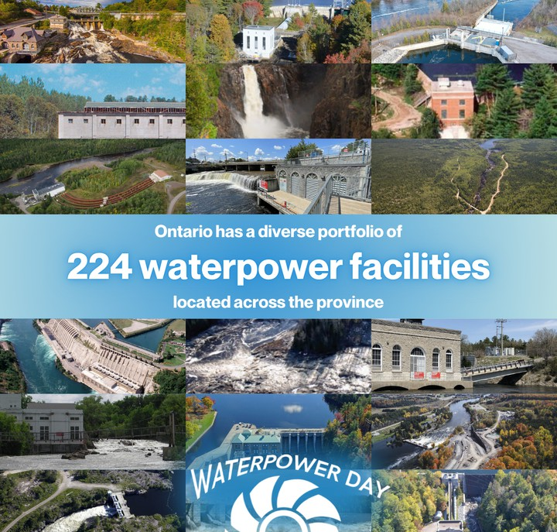Ontario has a diverse portfolio of 224 waterpower facilities located across the province. From historic generating stations to modern innovations, this renewable energy source continues to play a crucial role in accelerating Ontario’s electrification. #WaterpowerDay https://tinyurl.com/3yhyk4x5

[**Download Graphic Here**](https://owa.ca/wp-content/uploads/2025/03/Waterpower-Day-Graphic-6.png)

# LinkedIn Frames

**Update Your LinkedIn Profile Picture** Customize your LinkedIn profile picture with a waterpower banner. Upload your headshot into

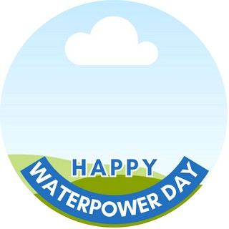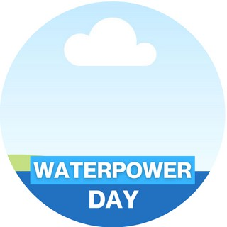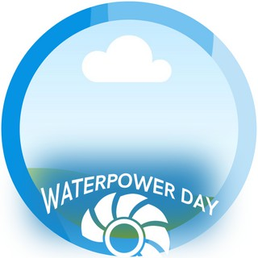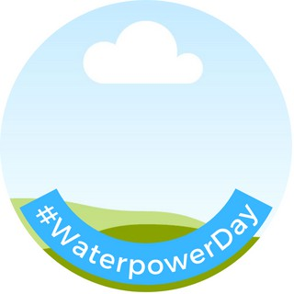our Canva template.



[**Canva Template - LinkedIn Frame**](https://www.canva.com/design/DAGFUftuR2s/J70ayoZstljVJ26kEbUh2Q/view?utm_content=DAGFUftuR2s&utm_campaign=designshare&utm_medium=link&utm_source=publishsharelink&mode=preview)

# More Information

**About Waterpower Day**

Waterpower Day is on June 20th. Waterpower Day was established to recognize the history and importance of waterpower in Ontario as well as the role it continues to play more than 100 years after the first waterpower facility came online. June 20th was selected for Waterpower Day in recognition of Sir Adam Beck (born June 20, 1857), a Canadian politician and waterpower advocate who founded the Hydro-Electric Power Commission of Ontario.



**Visit Our Website**

Check out our website to learn more about [waterpower day](https://owa.ca/waterpower-day/) and to access our [latest resources.](https://owa.ca/resources/)



# Thanks for Your Support!

We look forward to celebrating the history and future of made-in-Ontario waterpower with you on June 20.