IMPORTANT DETAILS

Waterpower Day Toolkit

Celebrate with the OWA on June 20

When is Waterpower Day?
June 20, 2024

Hashtags
#WaterpowerDay, #WaterpowerDay2024

Tag Us
LinkedIn: Ontario Waterpower Association
Instagram: onwaterpower
X: ONWaterpower

Questions?
Email Jan Fonseca, Communications Manager at jfonseca@owa.ca

Messaging and Graphics

Messaging and Graphics

To streamline participation, the OWA has created graphics and messaging for your use on social media. We encourage you to post on your personal platforms and to share this toolkit with your company's communications team.

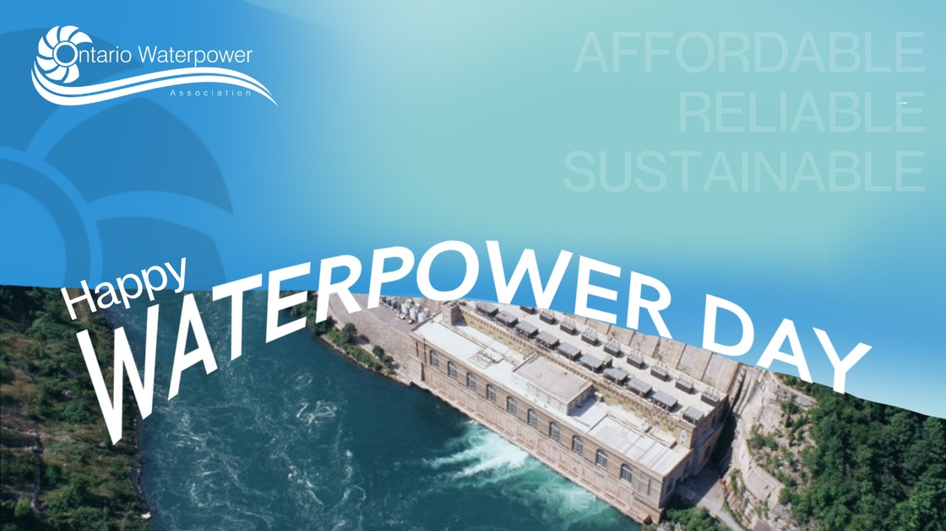
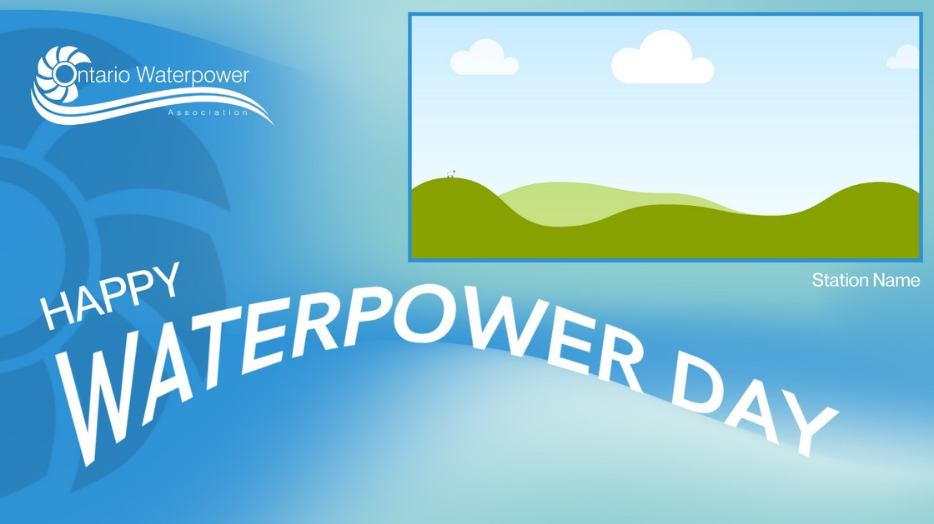
Waterpower is the backbone of the renewable energy
sector. It is a full service technology - contributing capacity, energy and to meeting peak electricity demands. As decarbonization and electrification increase, flexible waterpower will play an even more important role in integrating other renewable resources. Happy #WaterpowerDay! https://bit.ly/3QPVlRl

Download Graphic Here

Happy #WaterpowerDay, everyone! We're proud to
support Made-in-Ontario waterpower and recognize the tremendous benefits it brings to our province.
Waterpower provides affordable, reliable, and sustainable electricity to our grid and has significant economic and environmental benefits. Let's celebrate the power of water and its contribution to Ontario's future. https://bit.ly/3QPVlRl

Canva Template - Add your own photo

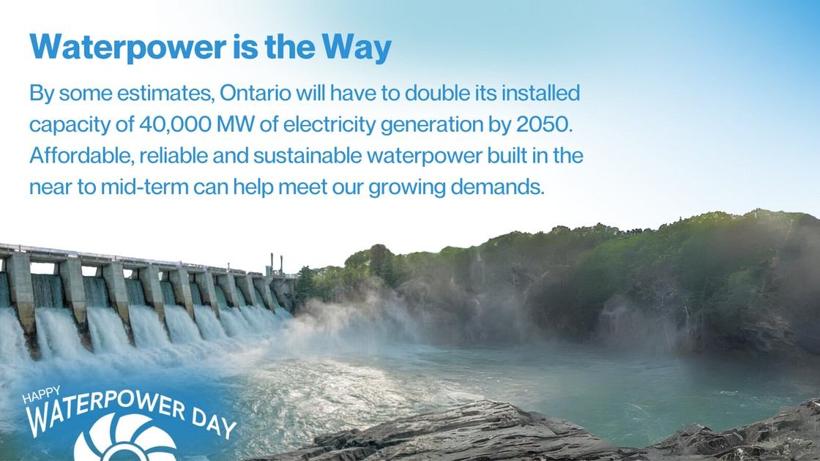
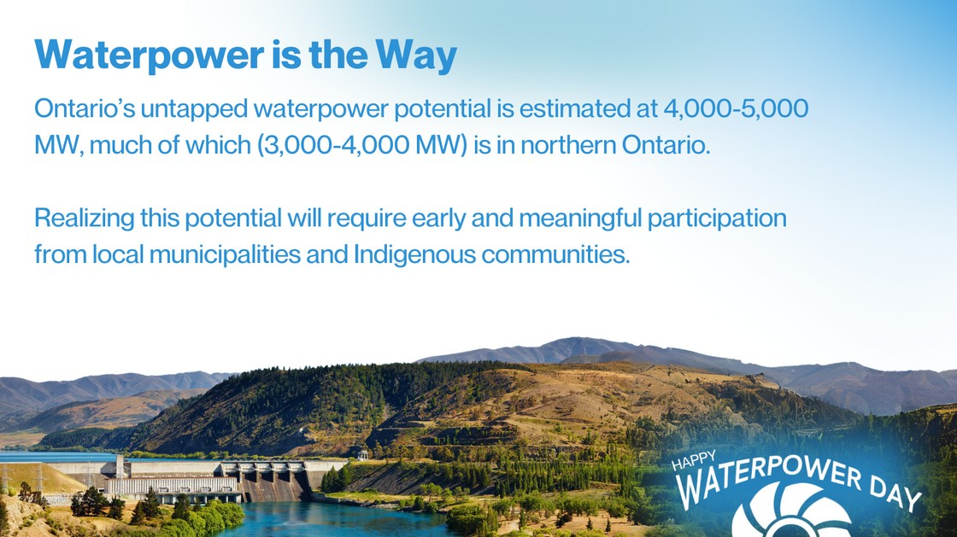
Today is #WaterpowerDay! Did you know Ontario will
have to double its installed capacity of 40,000 MW of electricity generation by 2050? Investing in waterpower can help meet system needs and provide significant local, regional, and provincial socio-economic benefits for communities. Waterpower is the way and the time to invest is now. https://bit.ly/47OjNs4

Download Graphic Here

Happy #WaterpowerDay! In Ontario, 4,000 - 5,000 MW of both new and expanded waterpower has been identified which can be built in the near to mid-term. It’s time to secure the province’s clean energy future. https://bit.ly/4apJJNs

Download Graphic Here

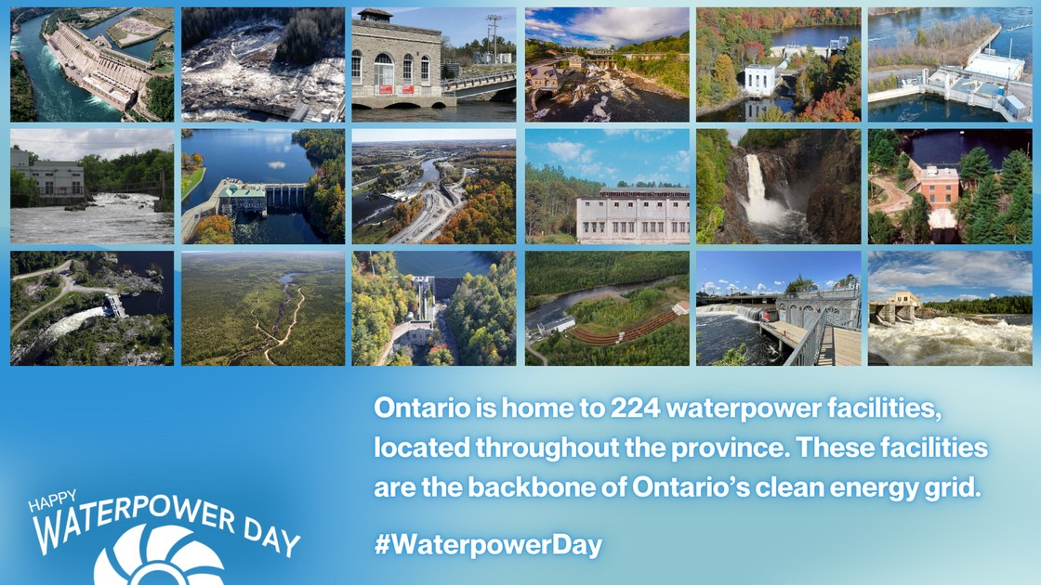
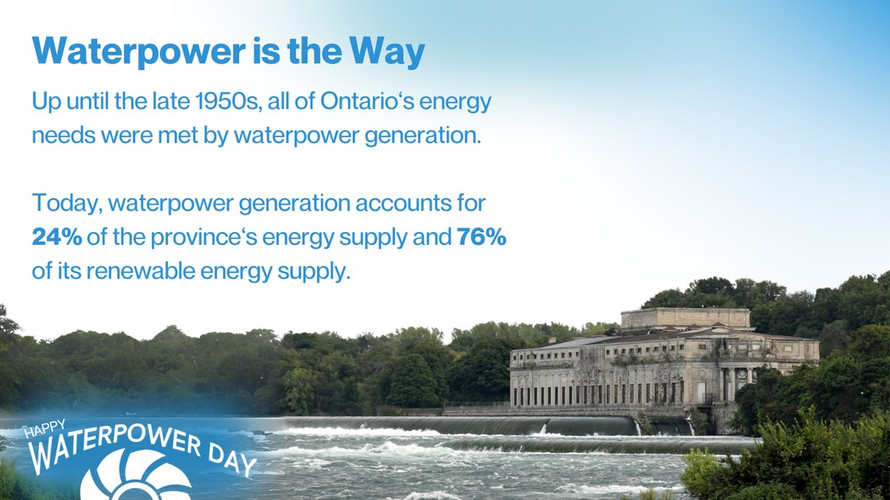

Happy #WaterpowerDay! Did you know that
waterpower facilities are perpetual assets? In fact, dozens of waterpower facilities across Ontario are 100+ years young. https://bit.ly/3QPVlRl

Download Graphic Here

Today we celebrate #WaterpowerDay! Ontario benefits
from one of the cleanest electricity grids in the world thanks to affordable, reliable, and sustainable waterpower generation. In fact, 25% of our energy comes from waterpower - now that’s something to celebrate! https://bit.ly/47OjNs4

Download Graphic Here

More Ways to Celebrate
Customize your LinkedIn profile picture and share our “Celebrate Waterpower Day” Video

More Ways to
Celebrate

Share our Video
Download and share our “Celebrate Waterpower Day” video on social media.

Video Link

Update Your LinkedIn Profile Picture Customize your LinkedIn profile picture with a pre-designed banner. Simply upload your
headshot into the Canva template.

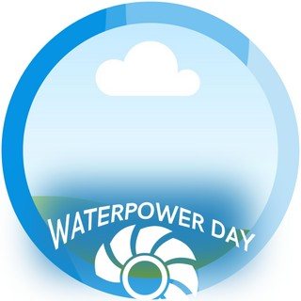
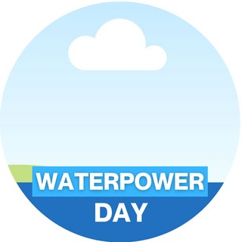
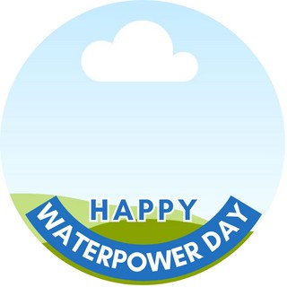
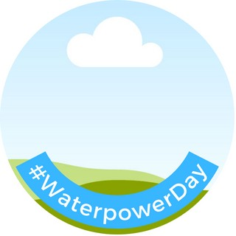
Canva Template - LinkedIn Frame

More Information
About Waterpower Day
Waterpower Day is on June 20th. Waterpower Day was established to recognize the history and importance of waterpower in Ontario as well as the role it continues to play more than 100 years after the first waterpower facility came online. June 20th was selected for Waterpower Day in recognition of Sir Adam Beck (born June 20, 1857), a Canadian politician and waterpower advocate who founded the Hydro-Electric Power Commission of Ontario.

Visit Our Website
Check out our website to learn more about waterpower day and to access our latest resources.

Thank You for Your Support!

We look forward to celebrating the history and future of made-in-Ontario waterpower with you on June 20.

